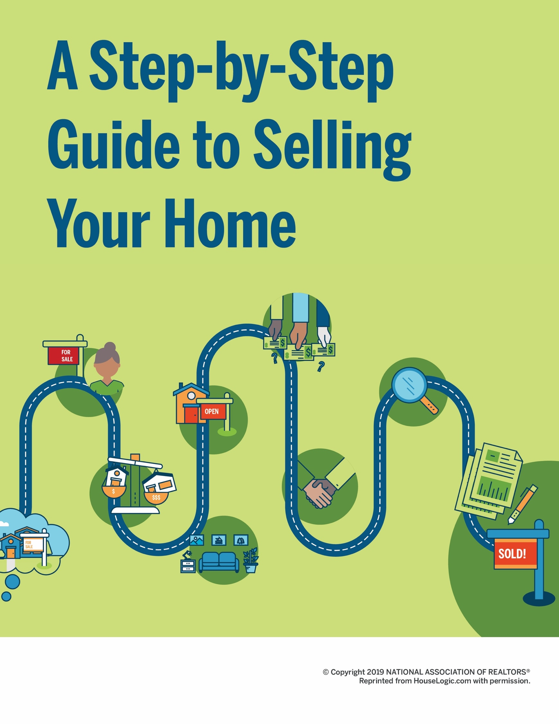

A STEP-BY- STEP GUIDE TO SELLING YOUR HOME
Table of Contents

3 | The Everything Guide to Selling Your First Home
5 | Sell Your Home: Step-by-Step
8 | The Ultimate "Let's Sell This House!" Checklist
11 | What You Need to Know About Researching Home Prices
15 | How to Find the Right Person to Sell Your House
20 | The Ins and Outs of Setting a Price for Your Home
24 | Staging Your Home: How to Make Buyers Fall in Love
28 | 10 Tricks for Hosting an Open House That Make Buyers Say “OMG, Wow!”
33 | What You Need to Know Before Accepting — or Rejecting — an Offer
38 | Your Guide to Negotiating an Offer
42 | A Seller’s Guide to Navigating the Home Inspection

47 | What Every Seller Needs to Know About Closing

THE EVERYTHING GUIDE TO
Selling Your First Home
How to figure out exactly what you want, and how to work with the experts who’ll help you get it.

Selling, a famous salesman once said, is essentially a transfer of feelings.
You love and cherish your home. You want the next owner to fall in love with it, too — through photos, through words, and through the experience of walking through your front door. But, perhaps most, you want to get the price you want.

This isn’t a small task. Selling a home requires work. It requires time. The journey isn’t always easy. There will be frustrations. But when you seal the deal and move on to your next chapter — wow, what a blissful, boss feeling.

Below, we preview each step in your journey. We’ll discuss how to know what you want (and what your partner wants, if you’re selling together). How to understand the market, and ways to make a plan. And most importantly? How to create relationships with experts and trust them to help you get the job done. Now, let’s talk about selling your house.

Know, Exactly, What You Want
First things first: You need to know what you want (and what your partner wants) in order to sell your home with minimum frustration. Why are you moving? What do you expect from the process? When, exactly, should you put that For Sale sign in the yard? We can help you get your thoughts in order with this home selling worksheet on page 8.

Do Your Research
Unless you bought your home last week, the housing market changed since you became a homeowner. Mortgage rates fluctuate, inventory shifts over time — these are just a few of the factors that affect the state of the market, and every market is unique. Educate yourself on what to expect.

Interview and Select an Agent
This is the most important relationship you’ll form on your home selling journey. Pick the right agent and you’ll likely get a better sales price for your house.

Price Your Home
How much is your home worth? That’s the … $300,000 question. Whatever the number, you need to know it. This is how your agent will help you pinpoint the price.

Prep Your Home for Sale
Today, home buyers have unfettered access to property listings online, so you have to make a great first impression — on the internet and IRL. That means you’ll have to declutter all the stuff you’ve accumulated over the years, make any necessary repairs, and get your home in swoon-worthy condition. Here’s how to stage your home.

Market Your Home
Home buyers look at countless listings online. The best-marketed homes have beautiful photos and compelling property descriptions, so they can get likes — which can amount to buyer interest — on social media. Some agents are even using videos, virtual tours, texts, and audio messages. It’s time to consider how to promote your property.

Showcase Your Home
One of the best ways to get buyers in the door is to have an open house. This is your chance to show off your home’s best assets, and help buyers envision themselves living there. Know how your agent will organize, advertise, and host the event to ensure it’s a success.

Negotiate With the Buyer
To get the best deal for you, you’ll likely have to do some negotiating. Your agent will help you craft a strategic counteroffer to the buyer’s offer, factoring in not only money, but contingencies, etc. Let’s talk about how to ask for what you want.

Negotiate Home Inspection Repairs
Ah, the home inspection. It’s as much a source of anxiety for buyers as it is for sellers. Nonetheless, most purchase agreements are contingent on a home inspection (plus an appraisal, which will be managed by the buyer’s lender). This gives the buyer the ability to inspect the home from top to bottom and request repairs — some even could be required per building codes. The upshot: You have some room to negotiate, including about certain repairs. Once again, your agent will be there to help you effectively communicate with the buyer.

Close the Sale
Settlement, or closing, is the last step in the home selling process. This is where you sign the final paperwork, make this whole thing official, and collect your check. Before that can happen though, you’ll have to prepare your home for the buyer’s final walk-through and troubleshoot any last-minute issues.

We’ve got you covered.

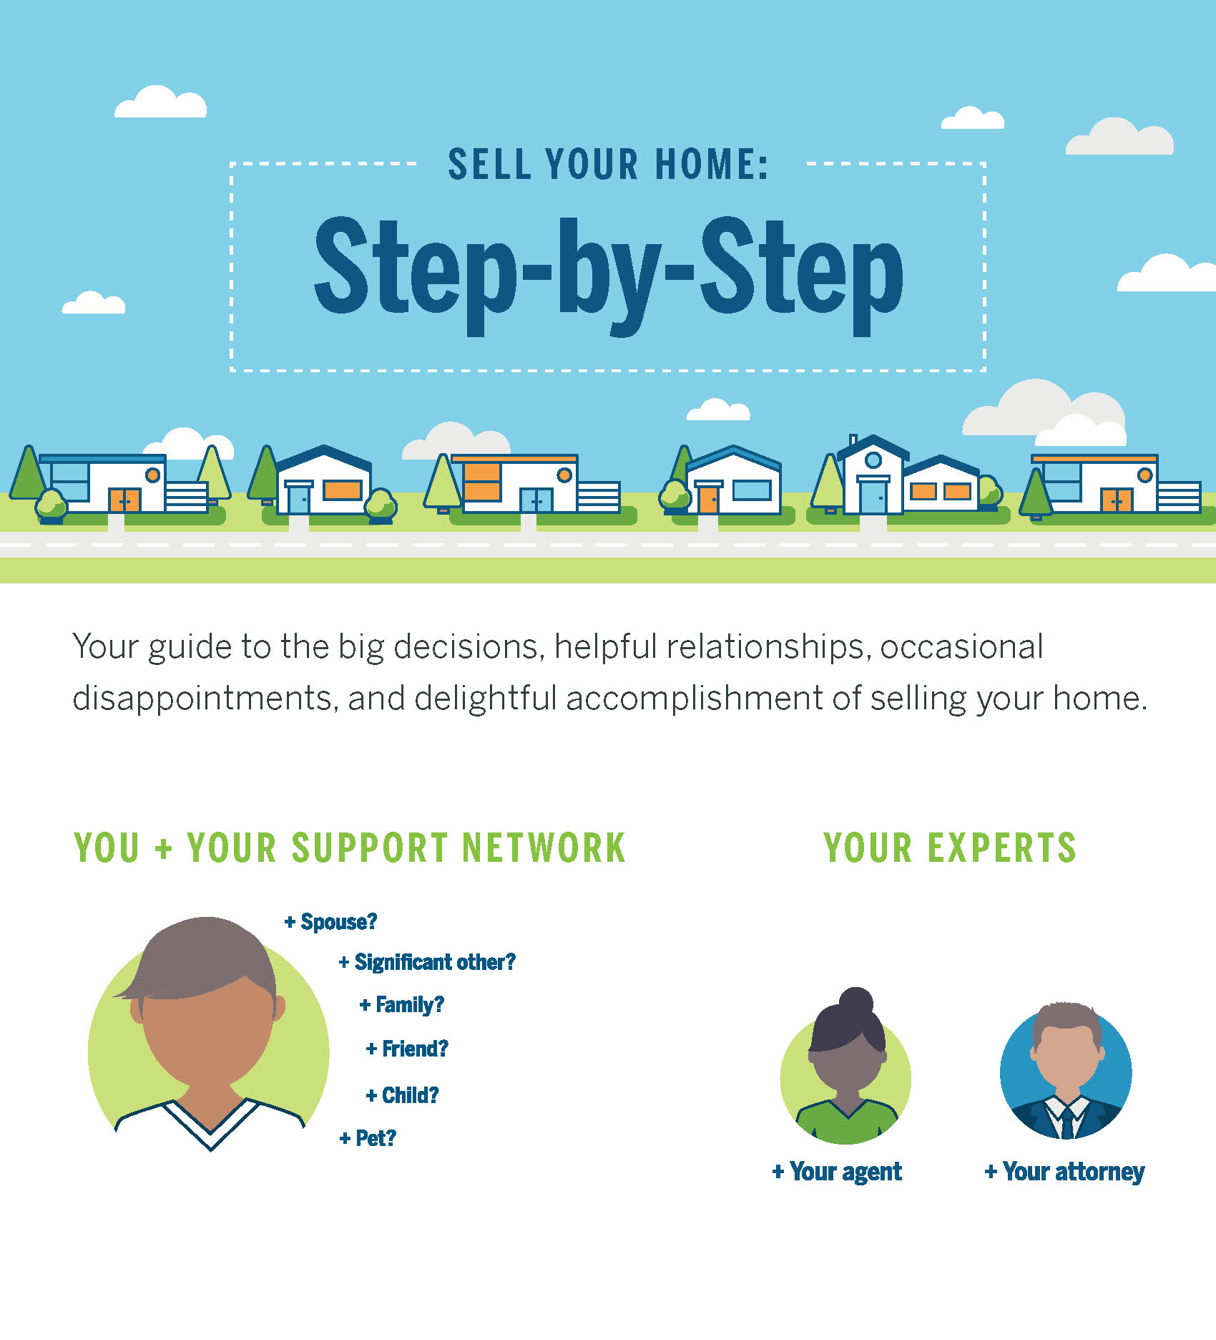
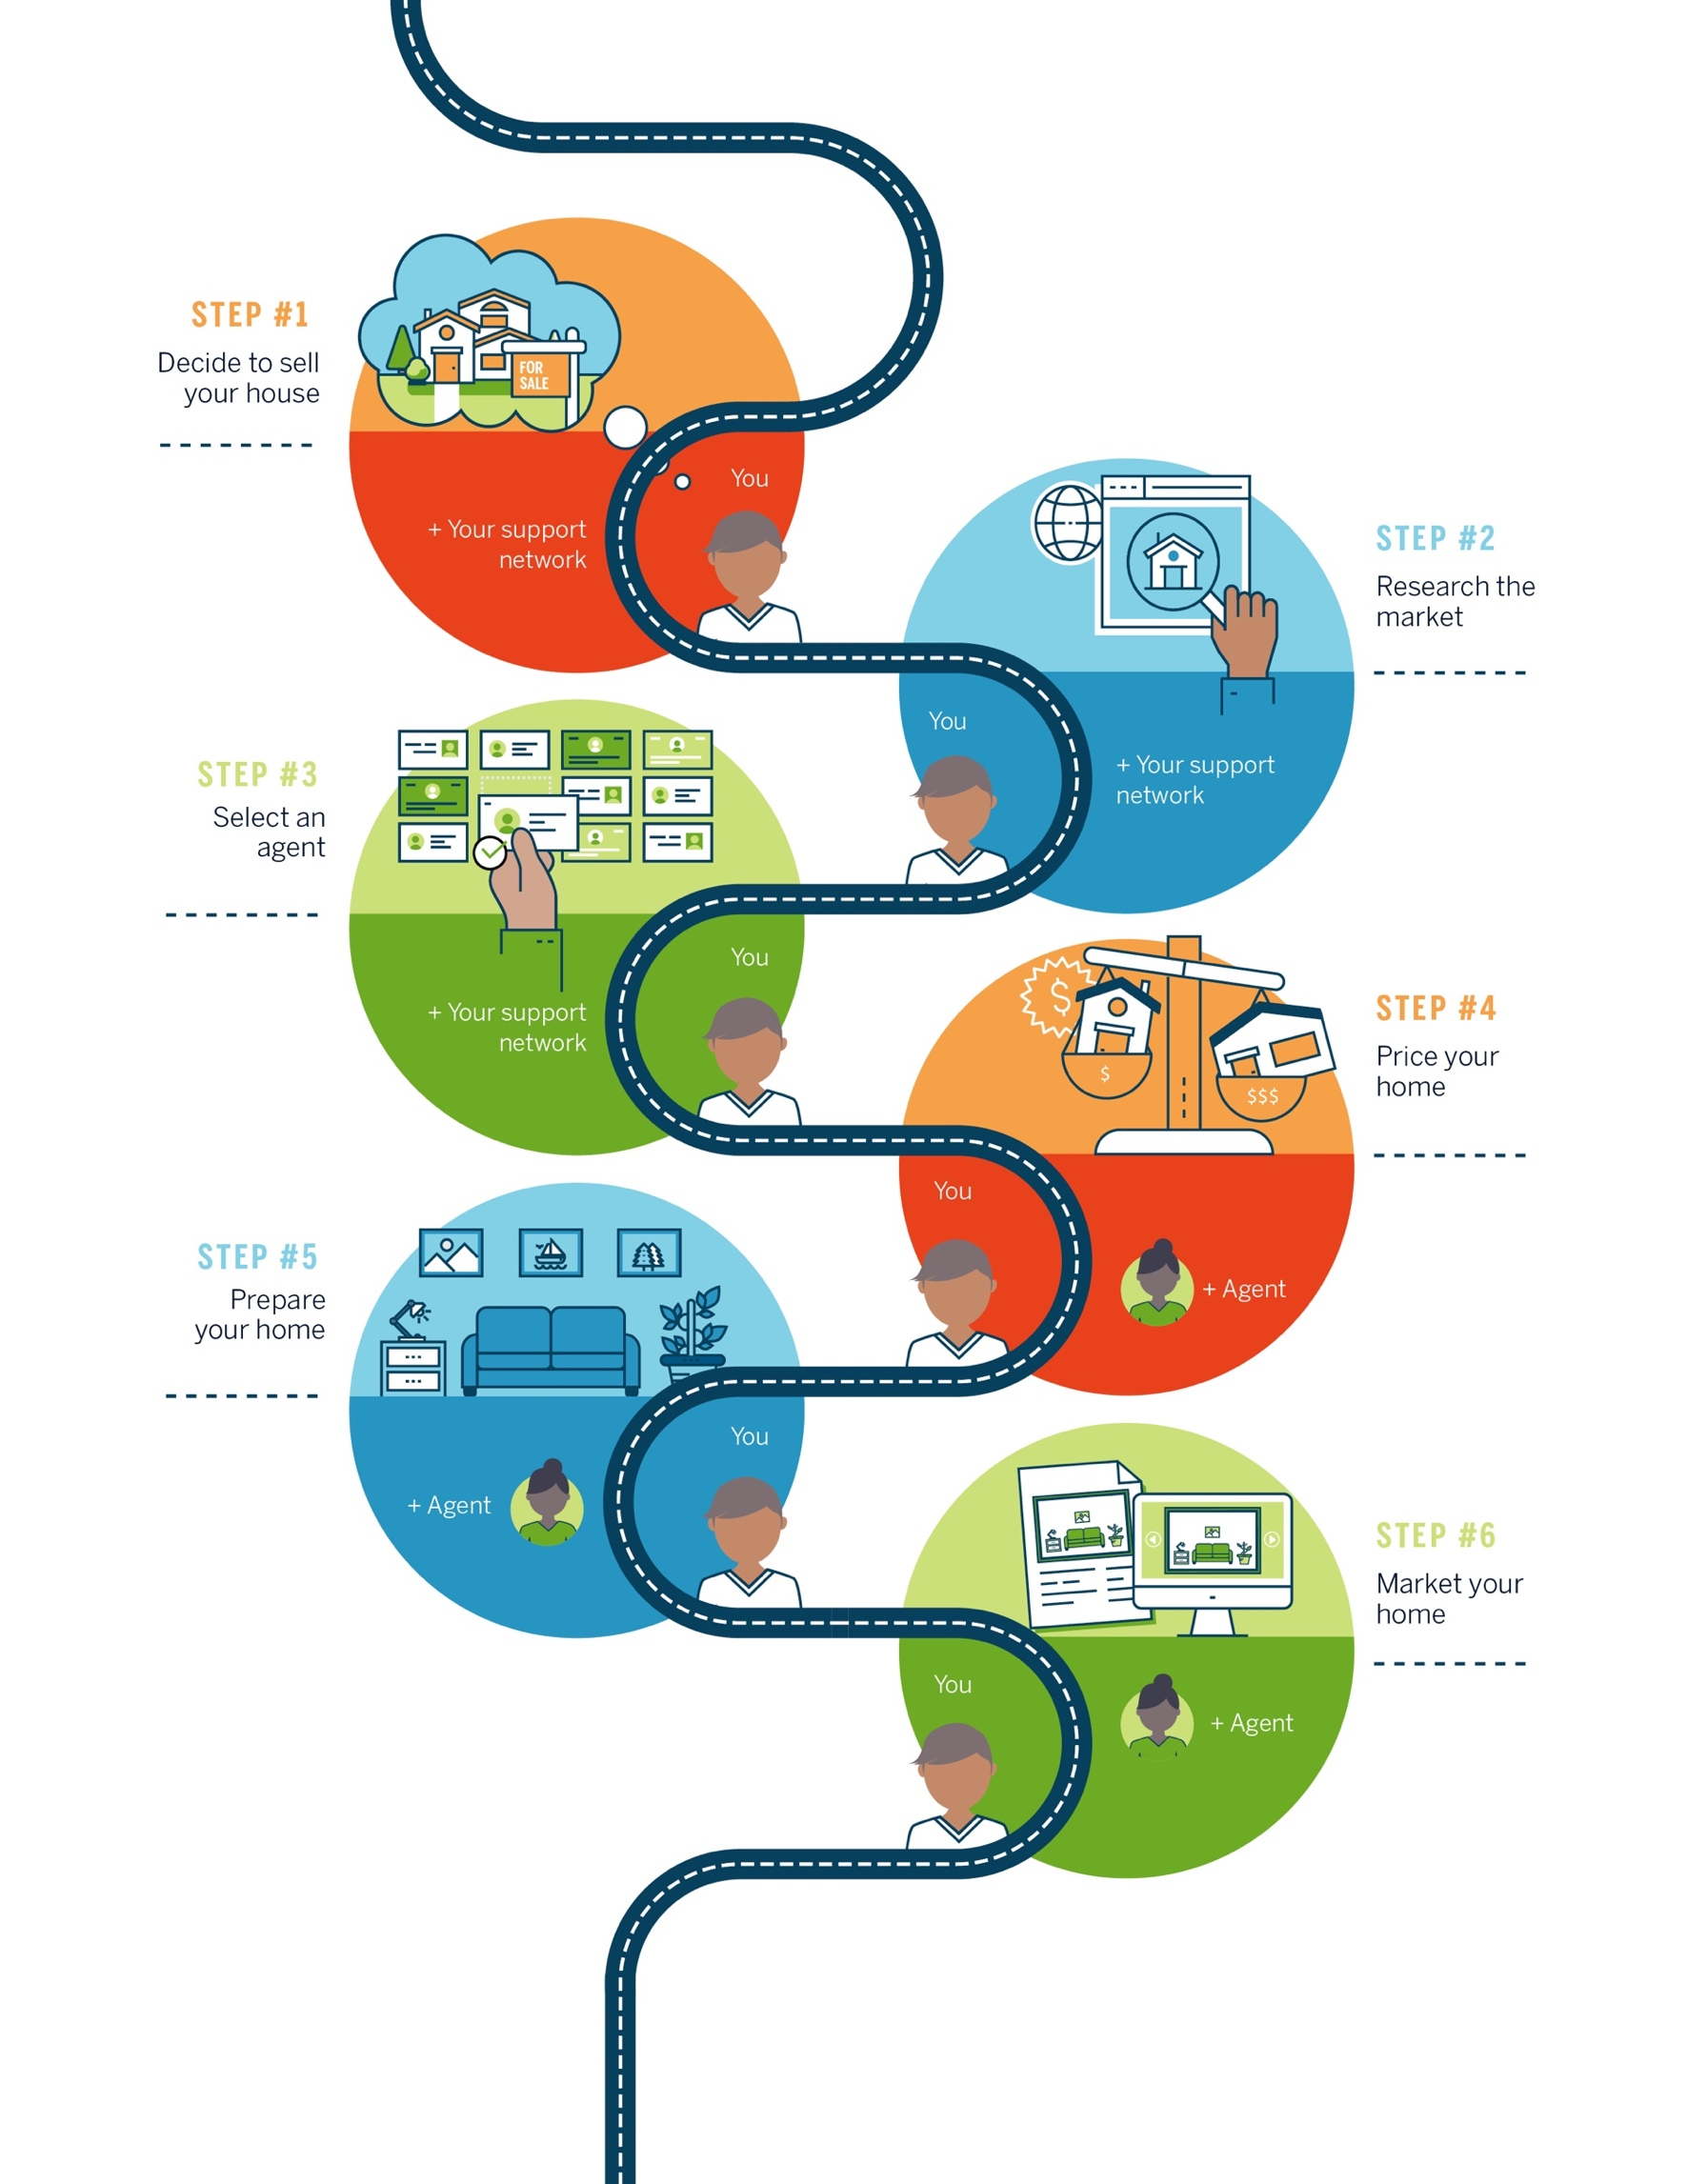
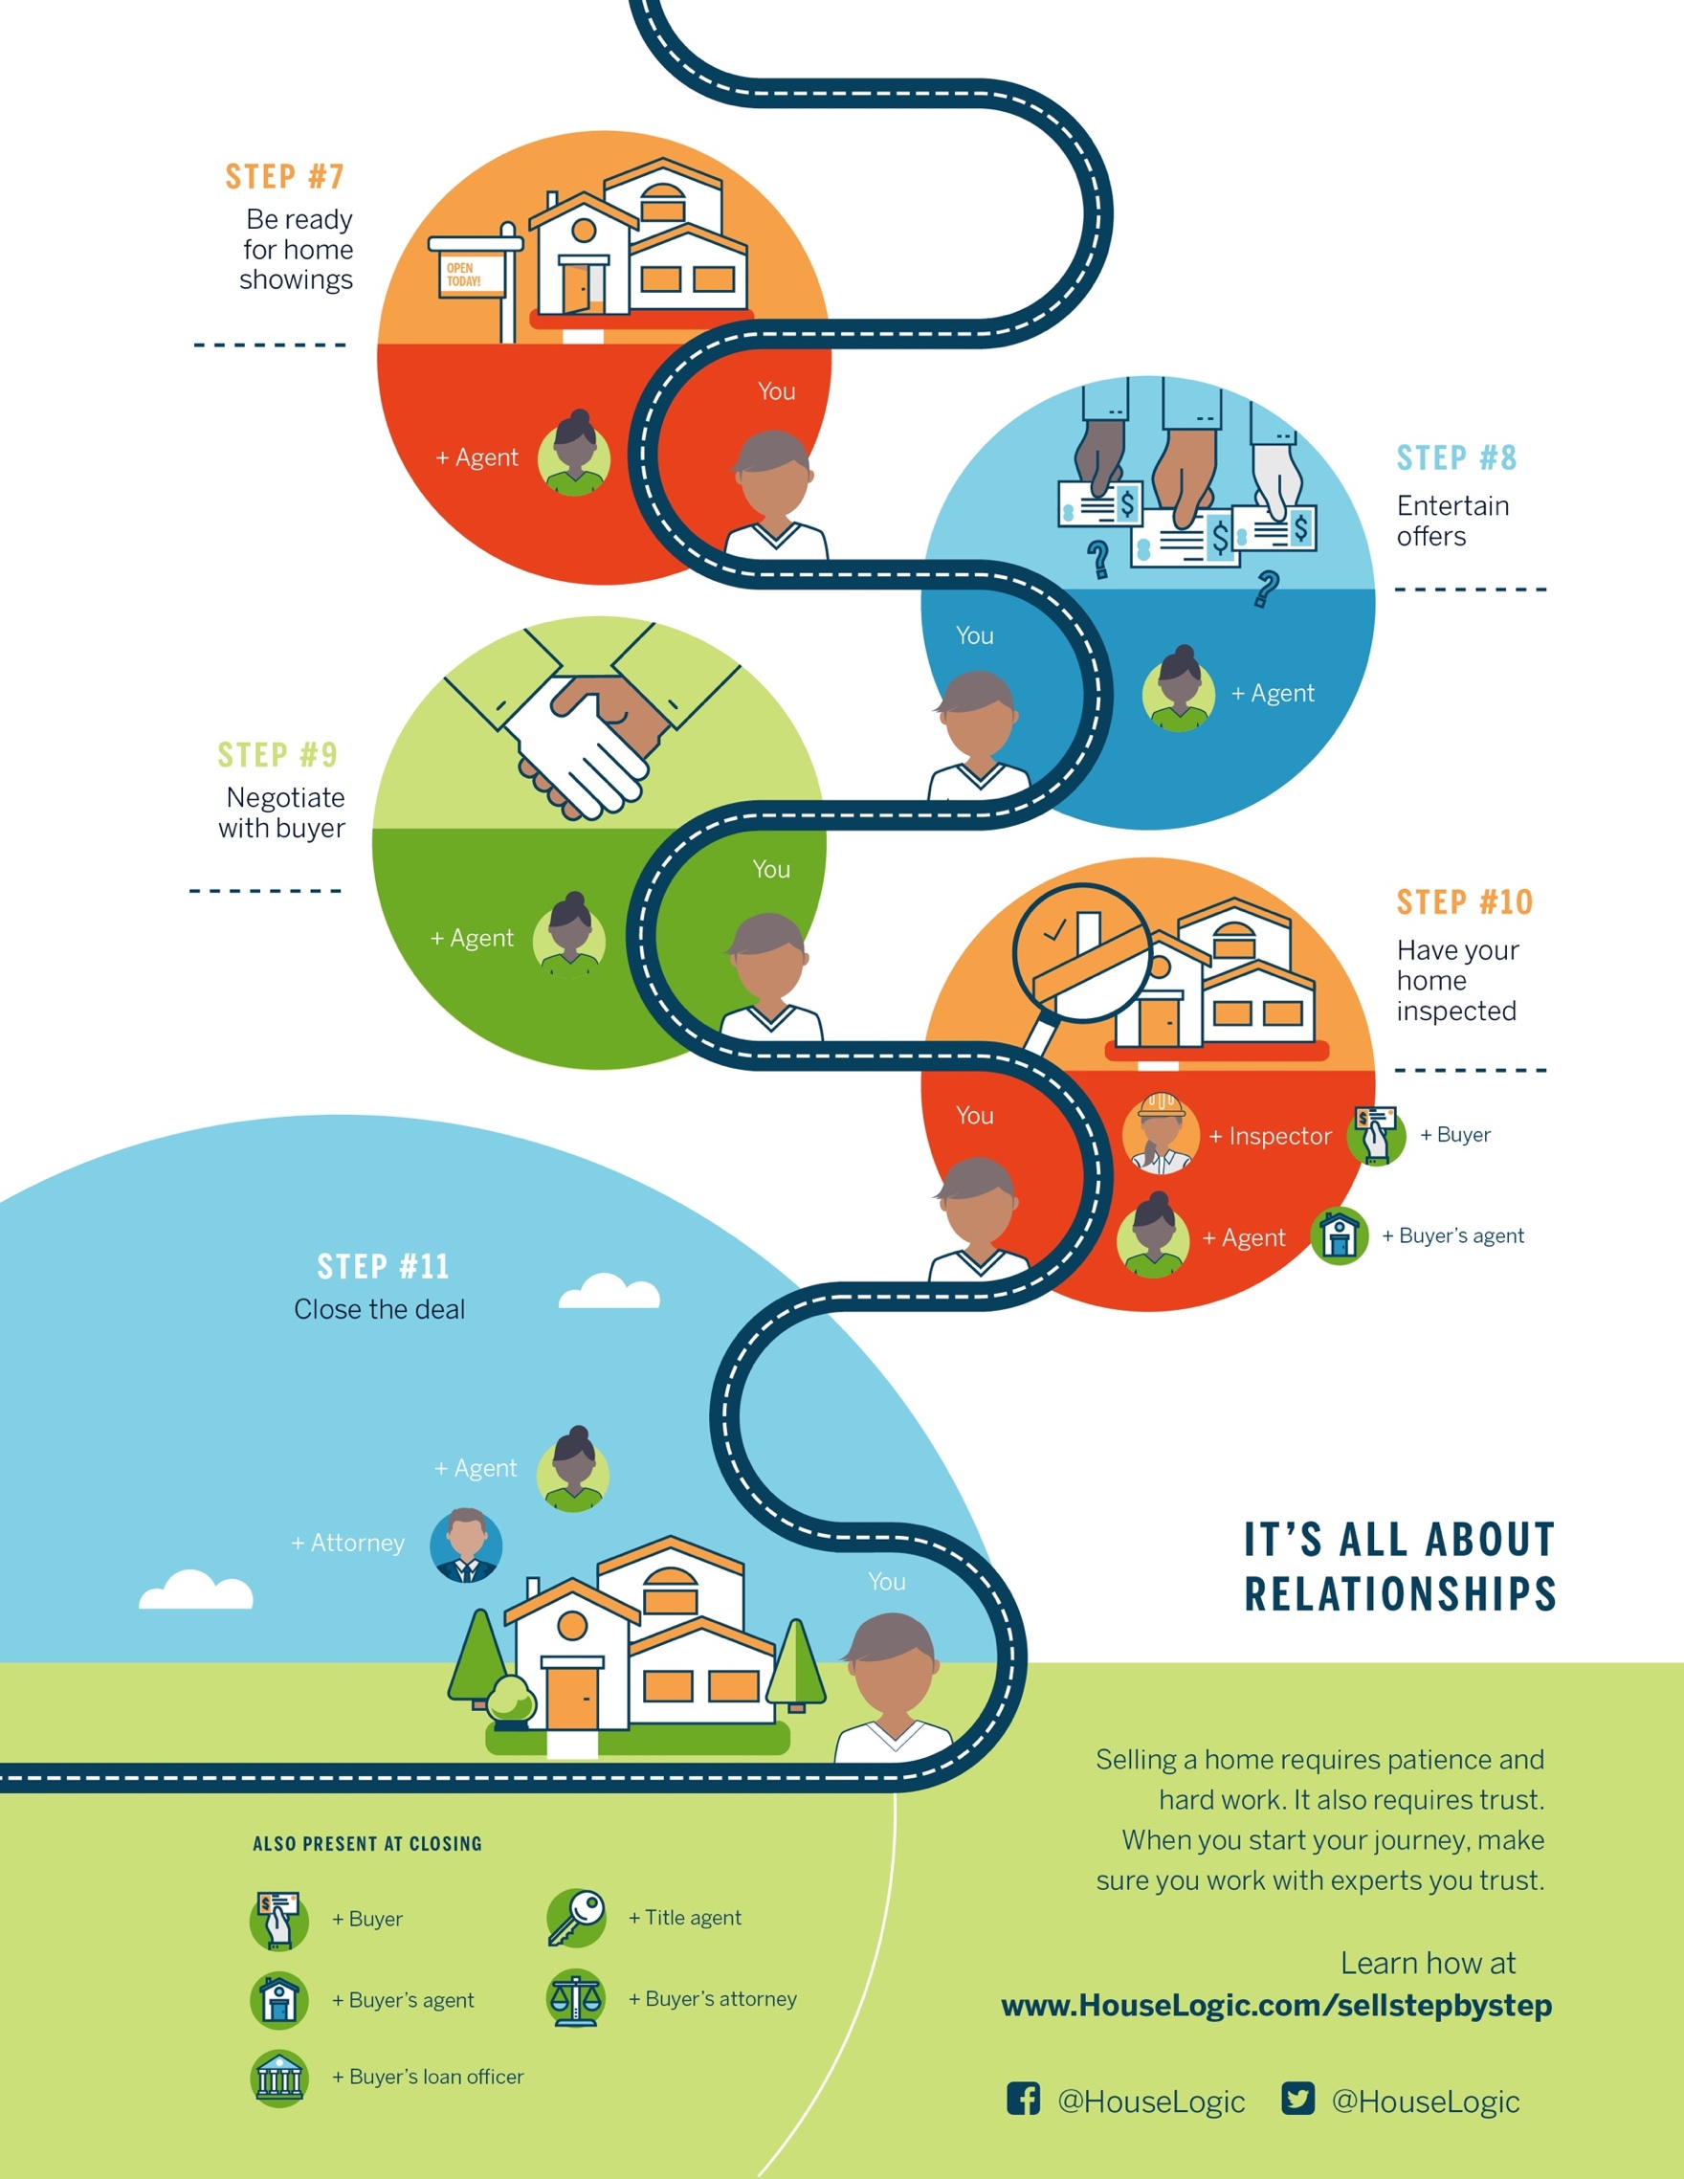
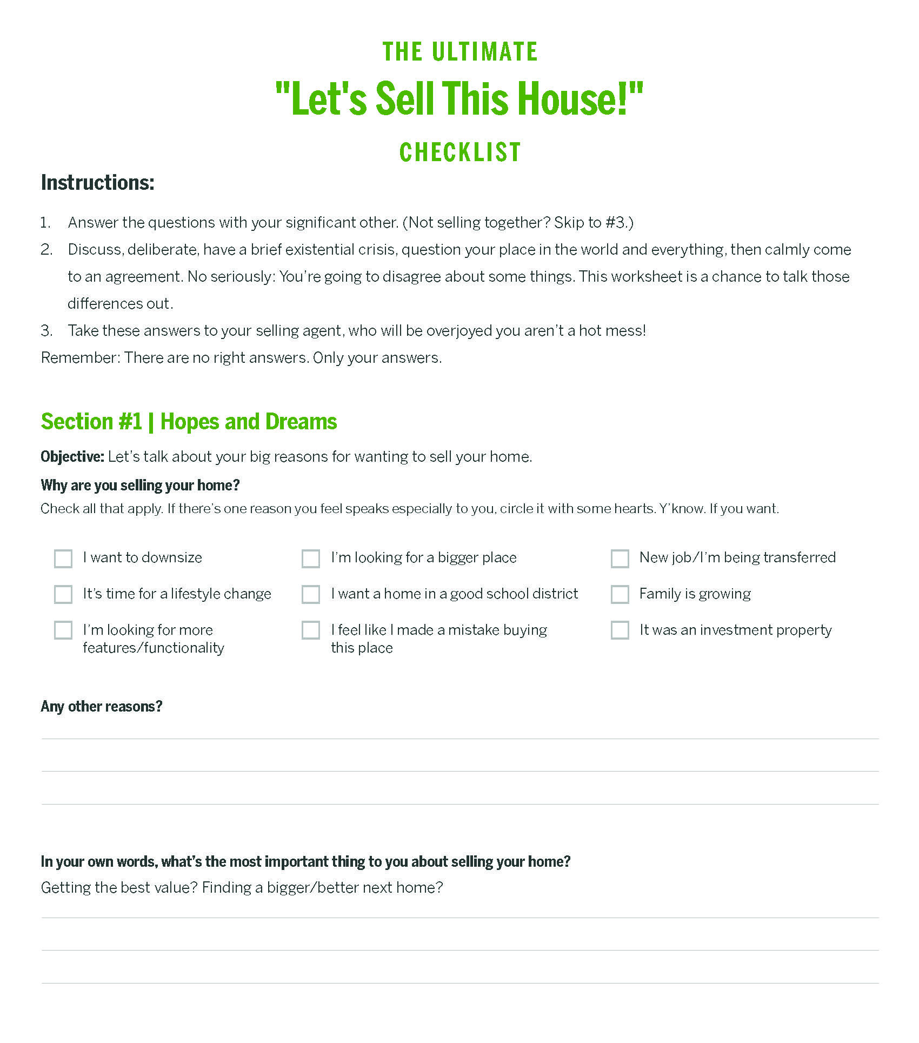
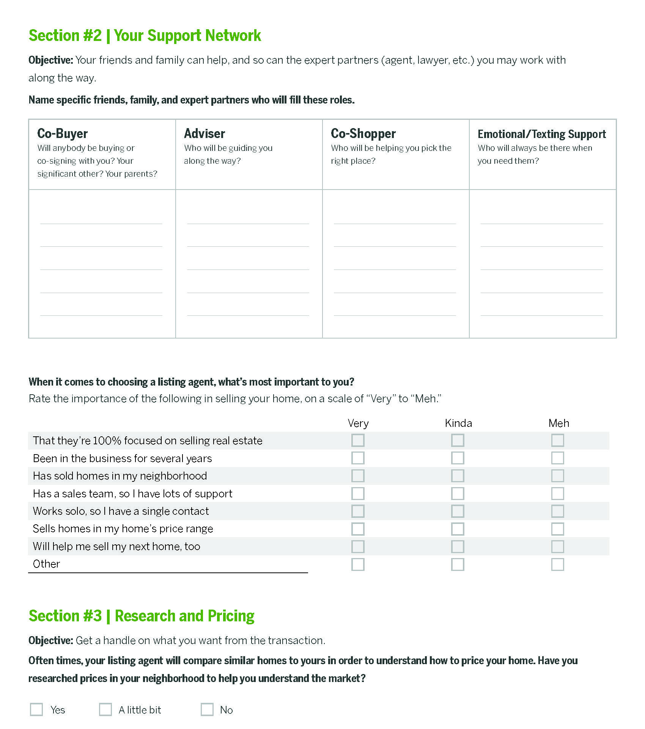
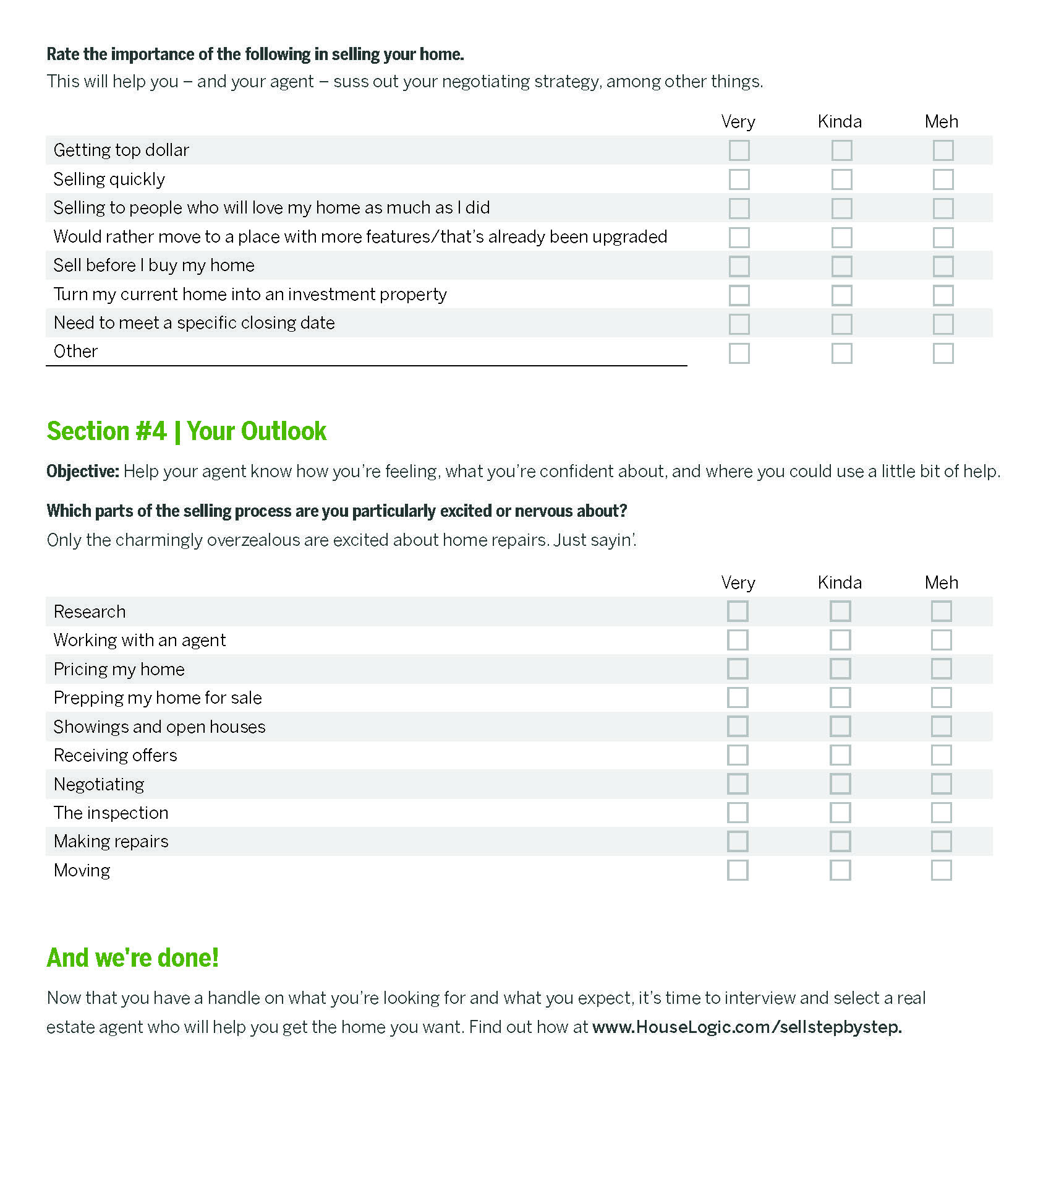

WHAT YOU NEED TO KNOW ABOUT
Researching Home Prices
There are a lot of home pricing resources out there, and some are far better than others.

When it’s time to sell your house, you may be feeling a little anxious.
A chapter of your life is closing. There’s a lot of money on the table. You may be thinking “Is my house priced too high?” “Too low?” “Am I leaving too much money on the table?” These are big questions.

Luckily, you have a few resources at your disposal to figure out where your house stands among the crowd: a listing agent’s expertise and guidance, plus online property sites to get insight into the market.

So take a deep breath. Then do your homework. The more you know, the more confident you’ll be when it’s time to make those big decisions.

Turn to Local Experts — Because They Really Know Their Stuff
The good news: Local market info is freely available online, so you, the seller, can get a sense of what your house is worth.

The bad news: Local market info is freely available online, so most buyers will also have a general idea of what they think your home is worth.

When pricing your house, a listing agent has your back in a way an online property listing site just can’t. An agent:
- Has real world experience in your community.
- Knows the nuances of your neighborhood’s micro-market.
- Can expertly assess how your home compares to similar ones recently sold in your area.
- Can tour your property to determine, inside and out, where your house fits in the real estate landscape.

A website will do none of the above.

An agent will, yes, consider online market data to help you set the price of your home. But he or she will also rely on first-hand knowledge about your home’s unique perks (and quirks), as well as about the neighborhood, to better inform your listing price.

He or she can also recommend ways to market your house (Instagram-able photos, blog-worthy descriptions, etc.), pro stagers who can set your home up to dazzle buyers, and inspectors and contractors who can make any needed repairs.

That being said, you’ll want to have your own sense of what your house is worth too. As invaluable as a listing agent is to your selling journey, being the seller means you’re also the final decision maker.

So keep your laptop out. We’re going to do a little research.

Search Online Property Sites — Because They’ll Give IRL Experience Some Context
Millennials are the largest group of home buyers today, according to a NATIONAL ASSOCIATION OF REALTORS®’ (NAR) report, and they overwhelmingly start their buying journey — where else? — online.

The internet is there for you as well — to an extent — when you’re ready to sell your home.

Online property sites like realtor.com® can give you a sense of local real estate trends, including your city’s median listing price, median closing price, and the average price per square foot. As you search, there are a couple important things to do:

- Pay attention to houses in your area that are similar to your own in terms of size, attributes, and location. When you work with a listing agent to price your home, these houses will provide the main criteria for setting the amount.

- Take notes about what makes your house different from the pack. As you look at online listings, think carefully about why your house is worth more or less than similar houses in your community. The better you’re able to articulate these nuances to your listing agent, the better prepared the agent will be to list your home at an accurate and competitive price.

Having this information can also give you confidence in the price your agent ultimately recommends — you’ll know what’s standard for the market, and how the price determined for your house lines up. If there are discrepancies, talk to your agent about how he or she arrived at their price. Unlike the internet, he or she can give you a complete picture of what your home’s price should be and why.

Also, as you search, be aware that not all real estate listing sites are created equal. Realtor.com® aggregates listings from Multiple Listing Services (MLS) around the country, which provides the most up-to-the-minute data about home sales. (By the way, realtor.com® is the official listing site of NATIONAL ASSOCIATION OF REALTORS®, which operates HouseLogic.com.)

Most of ‘for sale’ listings at realtor.com®, for example, are refreshed every 15 minutes — so what you see is likely what you get. Another big property listing site (and brokerage), Redfin, also aggregates data from MLSs.

Trulia and Zillow, on the other hand, collect their listing information from a variety of sources, and may not always be as up to date as the MLS.

The takeaway: Seller, beware. Consider your online source. Take what you’ve learned from online listings to your agent to talk about what’s really best for you and your home.

Try Online Price Calculators — With Caveats
As long as you’re on the internet, you might decide to try an online home price calculator. With these calculators, property sites use sale prices near you (and overall market data) to approximately predict your own home’s value.

You’ll find an online home price calculator at almost any property site, and they all work a little differently. Realtor.com®’s home estimator tool (https://www.realtor.com/sell), for instance, factors in your home’s square footage and recent home sales in your area to calculate an approximate recommended sale price.

Plug your ZIP code or address into a site to see:
- Homes for sale in your community, which can give you a sense of the overall market
- Estimated prices of similar homes in your area, which can provide a general range of home prices in your area
- Property descriptions and photos of local homes for sale, which can give you a feel for how other homes are being marketed to buyers (and how you can do even better)

Info like this is good to know — particularly because most buyers will see similar numbers when they to online research, too — but you have to take what online home price calculators tell you with a grain of salt.

Online price calculators can be useful as a reference, but they have limitations in terms of their scope (they can’t read nuances of the market like a human can), as well as their reliability. Some, including Zillow’s Zestimate tool, which estimates market value, have been challenged by some users for inaccuracy.

Your listing agent’s knowledge and expertise are more reliable measures for determining your own home’s price — he or she knows the subtleties of your home, neighborhood, and real estate market inside and out. Before you and your agent can confer, don’t get your heart set on a sale price.

Speaking of: The sale price is one thing. Potential profit is another.

How much money you’ll pocket after selling your home depends on a number of factors, including the amount of debt you still owe on a current mortgage, property taxes, and your real estate agent’s commission. To get an idea of your potential profit margin, google "net proceeds calculator."

Again: These are only estimates. A lot of variables are at play between the time you set a sale price and the time you close. The home will be appraised and inspected, and those results could affect your out-of-pocket costs or the sale price. And you’ll likely be negotiating the price with buyers. So use a net proceeds calculator with some care.

OK, you’ve done your research.
Now it’s time to find that listing agent who’s right for you.

HOW TO FIND
The Right Person to Sell Your House
Your guide to hiring the listing agent who can set you up for success.

Your home is where you’ve lived and loved, where you’ve laughed and cried, where you’ve huddled and snuggled.
You’re the pea, your home is the pod. And you’ve been through a lot together.

Now that it’s time to put it on the market, you’re likely experiencing some sadness, plus plenty of anxiety. Because really: How often does your future depend on selling your past? If you’re a little overwhelmed, we don’t blame you.

But there’s also good news: You don’t have to go it alone. A listing agent has your back when it comes to the financials, like setting a listing price and marketing, staging, and making repairs to your house. He or she can also help you navigate more personal issues, such as your timeline, and what you’re hoping to achieve with the sale.

For all of those reasons, it’s important to find an expert who is right for you and your specific situation, and who can help you get what you want. Here’s how.

Know What a Listing Agent Can Do for You
Before you start interviewing prospective agents, have a clear sense of what you want to get out of the selling process. When so much money is on the table, it’s crucial to know what your goals are, so that you can find an agent who really speaks to them.
Then, it helps to understand what a listing agent does (other than sell your most valuable asset — no big deal).
The listing agent will:
- Work with you to price your home
- Market your home (we’re talking pretty pictures, social media promo, cute staging – the works)
- Negotiate with home buyers
- Usher the home sale through inspection and closing
Now, let’s break all of that down …

Pricing Your Home. This is the BIG question, right? How do I set the price? The short answer is you’ll need to trust your agent to recommend a smart listing price.

So how can you tell whether an agent — a relative stranger to you — is choosing the best price for your home? You need to do two things:

- Know, generally speaking, what your property is worth. Do your own research on the prices of local comps, (but understand the limits of online property sites). Run your info by your agent for an informed perspective.
- Ask the agent for pricing information on homes he or she has recently sold. Specifically, what the differences were between their listing prices and how much the homes ultimately sold for.

When it comes to the agent’s pricing history, you’re looking for accuracy. Anyone could suggest a high price for your home, knowing it’s what you’d like to hear. But nobody (especially you) wants to have a house languish on the market, or to reduce a price repeatedly.

Marketing Your Home. The listing agent will also get the word out that your house is on the market, using a combination of old-school (but powerful) marketing techniques — such as direct mail, signage, and open houses — and the modern methods we know and love, like social media. Savvy agents will post pics of your house on Instagram, Facebook, Twitter, and any other platform that can get likes plus the attention of other real estate agents who can bring buyers to the table.

Negotiating with Buyers. When offers start pouring in, your agent will negotiate with prospective buyers on not only the sale price but also on what contingencies (aka special circumstances) are attached to the
contract. As with any negotiation, there could be some stressful, fraught moments with the buyers. You’ll want an agent who can step up for you, and who has a negotiation style that you’re comfortable with.

Closing the Sale. Once you’ve signed a purchase agreement with a buyer (woo-hoo!), your agent will help you navigate the sale’s remaining steps. This includes negotiating home repair requests post inspection and dealing with any last-minute surprises before closing.

The average listing agent does all of the above. A great listing agent does all of the above, while also inspiring your confidence — that they’re getting the best price for you, and that they’re representing you and your home in the best possible light.

So, let’s talk about how to find and hire that kind of agent.

Ask These Questions to Find a
Great Listing Agent
Here, time is on your side. Aim to hire a listing agent six to eight weeks — or more — before the day your house is listed on the market (also known as the “go-live date”). You’ll be grateful for the cushion, especially if the agent you ultimately hire recommends that you make repairs or upgrades to your home before it’s listed. (That wouldn’t be unusual.)

To find prospective agents, start with your network. Ask friends, relatives, neighbors, and colleagues for recommendations. Word-of- mouth endorsements, as always, can be priceless.

You can also turn to another trusted friend: the internet. Property
websites such as realtor.com® have directories that let you search for agents in your area. These databases can clue you into important details, such as an agent’s years of experience, number of homes sold, and past client reviews.

Three out of four home sellers only contact one candidate before picking their listing agent, according to a NATIONAL ASSOCIATION OF REALTORS® report. While that may be the norm, it’s smarter to shop around. Interview at least three agents before deciding on the one you want to work with.

During the interviews, ask these questions to help assess whether an agent is
the right fit you:

- Do you work as an agent full-time? Like most professions, experience is no guarantee of skill. That said, much of real estate is learned on the job.

- How long have you been in the business? Generally, the more experience an agent has, the more they’re tapped into the local market.

- How many homes have you sold in my neighborhood in the past year? You don’t need to find an agent who specializes only in your community, though that would be ideal. You do want someone who has recently sold at least a few homes in your neighborhood and knows the local and hyper-local inventory.

- What’s the typical price range of homes you sell? Most agents work across multiple price points, but you don’t want an agent who has never sold a home in your range.

- What’s your fee? An agent should be able to articulate their value and explain their commission rate.

- How will you market my home? You don’t want to hire someone who’s just going to stick a For Sale sign in your yard and call it a day. The agent should present a comprehensive marketing plan for your listing
— this should include strategies for staging your home, taking professional photographs of your home, promoting the listing on social media, marketing to other brokers, scheduling open houses, etc.

- Will I be working with you directly, or with a team? Some agents lead or work as part of a sales team. The lead listing agent shares client responsibilities with other agents. Where one agent may handle private showings for a listing, another may host open houses. A benefit is that for the same fee, you get many people working for you. But if you want the sole attention of the listing agent, you may want to stick to a one-on-one arrangement.

- Will you provide one-on-one service? Whether you’re working with one agent or a team, ask how responsive they can be to you, your timeline, and your goals.

- How long on average are your listings on market? Your average sold-to-list price? This can help you suss out whether the agent is a solid marketer and negotiator. These are real estate stats that the agent can pull from your local multiple listing service, or MLS.

The bottom-line: It’s in your best interest to pick an agent who understands your goals, fits your personality, and can get your home sold for top dollar. When you meet someone who can offer all of the above, congratulations — you’ve found your listing agent.

First Thing: Know What You’re Signing up For
Now that you know what you’re getting when you find the right listing agent, let’s make sure you know what you’re committing to when you sign that agent’s “representation agreement.”

The most common type of representation agreement is the exclusive right-to-sell agreement — a legally binding contract that states you’re going to use that agent to sell your house. Under this agreement, you’re giving the agent (and the agent’s brokerage) the right to sell the home for a mutually agreed-upon time period and compensation. IOW: You get peace of mind that you have a dedicated agent; the agent gets peace of mind that you’re only using their services. Other common terms include the agent’s duties to you, like marketing, and a dispute resolution plan.

There are other types of representation agreements, where agents don’t have exclusive rights to sell the property — meaning multiple agents can try to sell the home and compete for the commission. However, when agents know a listing is exclusively theirs, they’re fully invested in selling the property (which, again, should also give you peace of mind).

Every contract has an expiration date, but the length of the contract can vary. Some are three-months; others six months. It all depends on what you and the agent agree upon. If the contract expires before your house is sold, you can re-list your home with another agent.

Of course, there’s a chance you sign an exclusive listing agreement but just aren’t satisfied with the job your agent is doing. To protect yourself, make sure the representation agreement has a cancellation or termination clause that lets you void the contract before the expiration date without any financial penalty.

Understand How a Listing Agent Gets Paid
So … at the end of the day, how do listing agents get compensated for their work?

Real estate commissions — including the listing agent’s commission — are typically charged as a percentage of the home’s sales price. For example, on a $300,000 house, a 6% commission would cost $18,000.
Commissions are negotiable. The commission is usually split between the listing agent and the buyer’s agent as well as their respective brokers.

A caveat: If an agent represents the seller and the buyer, the agent becomes a dual agent and earns both sides of the commission. In dual agency, you may have more room to negotiate the rate — just keep in mind that you’re not being represented exclusively as you are in single agency. You may want to hire an attorney to review documents and help you negotiate.

The listing agent’s commission fee often covers the cost of professional photos, marketing and marketing materials, and any administrative fees charged by the agent’s brokerage.

Also, consider this: Great agents — with their pretty photography, HGTV-worthy staging tricks, and marketing smarts — earn their keep.

So, if you’ve read all of the above, you’ve done your homework to find a great agent. Now you’re ready to sell that house.

THE INS AND OUTS OF
Setting a Price for Your Home
It’s a big decision with a lot of factors, but don’t worry — you have backup.

Everything has value. Especially your home.
And when it comes to selling your home, assigning a price to that value is complicated. You made memories there. You’ve got a major financial interest in the place, too.

Buyers think of value, but they’re more concerned with price. And your home’s price is one of its most attractive — or unattractive — features. The right price can attract buyers, quickly. The wrong price may mean the house sits on the market, which can create the vibe among buyers that there’s something wrong it. (If the home buying process is Instagram, think of a wrongly priced home as a photo that isn’t getting any likes.)

It’s your agent’s job, as the real estate expert — mining his or her expertise and knowledge of the market — to determine the best price for your home. But it’s your house. You need to have your own idea of how much your property is worth. Here’s how to get it.

Work With Your Agent
This is crucial. Your agent brings the right mix of industry expertise and knowledge of your local market to the table.

To understand whether your agent is pricing your home properly, read through each of the steps below. Use what you learn about your home’s fair market price to evaluate any price your agent recommends.

Throughout the pricing process, a good agent will:
- Listen to your needs
- Take into account your research
- Use his or her knowledge of the local market to help you pick the best asking price

You’re a team. It’s in both of your interests to price your home correctly — a timely, profitable sale is win for everyone.

And Yeah, You Should Also Check the Internet
Pricing a home is both art and science. To understand what will inform your agent’s pricing decisions — and to be prepared to bring your own educated input to the conversation — start with a pricing research phase.

This includes taking advantage of online estimating tools — but only to an extent. Property websites like realtor.com® and Redfin enable you to plug in your home’s address to see approximately how much your house is worth. They base their estimates on your home’s square footage and real estate data they’ve collected, such as recent home sales in your local market.

But those results are estimates based on generalized factors, not your unique situation. If at any point the price you see in an online calculator doesn’t align with what your agent suggests, prioritize the agent’s advice.

Online estimators also have a reputation among real estate professionals for misleading buyers and sellers alike with less-than-optimal pricing information. But as a starting point, they have their utility.

Know Your Local History
What your home’s listing price should be largely depends on what similar homes, or “comps,” recently sold for in your area. To price your home, your agent will run the average sales prices of at least three comps to assess your home’s value.

What constitutes a comp? A number of factors, including a home’s:
- Age
- Location
- Square footage
- Number of bedrooms and bathrooms

Agents will look into the difference between each comp’s listing price, and the price it sold for. He or she will consider price reductions and why they happened, if relevant. All the while, your agent will also rely on inside knowledge of housing stock and the local market. That nuanced understanding is invaluable, particularly when measuring the unique aspects of your home with raw data about comps.

When selecting comps, agents generally look for properties that sold within a one-mile radius of your home, and in the past 90 days. They find these homes using the multiple listing service (MLS), a regional database of homes that agents pay dues to access.

Size Up the Competition
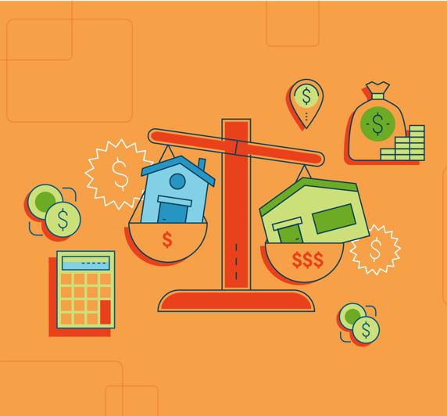
In addition to recently sold homes, your agent will also look at properties that are currently for sale in your area. These listings will be your competition. But because listing photos don’t always tell the full story, a good agent will check out these homes in person to see what condition they’re in and to assess how your home sizes up.

You can do the same. For additional perspective, you can also get in touch with your local association of REALTORS®. Ask if they have information to offer about your neighborhood and the local market.

Understand the Market You’re In
The housing market where you live can greatly impact your pricing strategy.

If you’re in a seller’s market, where demand from buyers outpaces the number of homes for sale, you may be able to price your home slightly higher than market value.

But if you’re in a buyer’s market, where buyers have the advantage, you may have to price your home slightly below market value to get people interested.

You can see local market trends by checking the online resource realtor.com®. It offers charts that display important housing market data, such as a city’s average listing price, median sales price, and average days a home is on market. It’s a lot of information. At any point, you can ask your agent to help you make sense of how your local market will influence your home’s price.

Put Your Feelings Aside
As previously mentioned, many sellers think their home is worth more than it is. Why? Because memories. Because sentiment. Because pride.

But you have to stay objective when assessing your home’s value. Buyers, after all, won’t know your home’s personal history. What makes your home special to you may not be something that entices them. Read: They may want to convert that craft room you worked so hard to perfect into a man cave.

The lesson: As much as possible, set aside your emotional attachment to your home. It will make it easier to accept your agent’s realistic, clear-eyed calculation of its price.

Remember: It’s All Relative
As you and your agent are talking price, the local market may throw you a curveball or two. In some markets, for example, it could make sense to price your home slightly below its fair market value to spark a bidding war.

Of course, there’s no guarantee a pricing strategy such as this will pay off. Similarly, there’s no one-size-fits-all playbook. Your home should be priced for its own local, or even hyper-local, market. Period. Confer with your agent before you decide to try any market-specific pricing tactics.

Be Savvy With the Dollar Amount
Pricing your home requires careful attention. In some cases, fair market value may not be precisely what you should list it for — and the reasons can be subtle.

For example, if comps show that your home is worth $410,000, setting that as your asking price can backfire
— the reason is that buyers who are looking online for properties under $400,000 won’t see your home in search results in that case. This explains why many agents use the “99” pricing strategy and, for example, list
$400,000 homes for $399,000. The idea is to maximize exposure.

Have a Heart-to-Heart With Your Partner
Not the sole decision maker in your household? Talk to your partner about your home’s price before it’s listed. You can use the worksheet on page 8 as a guide for that discussion.

The reason isn’t just to foster the kind of open communication that’s important to any relationship. It’s that if you’re not on the same page about price or the other things that are important to you about sale, each subsequent step of the selling process will be impacted by that tension.

Keep Your Head in the Game
You’ve considered your agent’s advice, and the two of you have agreed on the right price for your home. Hey, champ! Your house is on the market.

Even after the listing date, price should be an ongoing discussion between you and your agent. Markets are fluid, so it’s possible that you’ll have to make tweaks.

In any case, it’s important to stay in continuous dialogue with your agent, the MVP of Team Sell Your House. Together, keep your eyes on the price.

STAGING YOUR HOME:
How to Make Buyers Fall in Love
With these tips and tricks, your house will be swoon-worthy in no time.

All the world’s a stage, said the Bard.
That includes your house. Which is for sale. And thus needs to look bee-yoo-tee-ful.

Staging entails hiring experts with a flair for interior design. They reimagine your living space and give your house a makeover (with temporary decor and furnishings) so that it gets “oohs” and “aahs” from the buying masses.

Great staging isn’t an insurance policy — there’s no guarantee it will bring in more money when you sell your home — but it’s an important marketing tool. It presents your house in a flattering light and helps you compete at a favorable price. (In that sense, staging is like dressing your house for the price you want, and not the price you have.)

Staging also leads to eye-catching listing photos, which are especially valuable given that most home buyers begin their search by scrolling through listings online.

So, are you thinking about hiring stagers for your home? Here’s what to consider.

Staging Really Does Help. Like, a Lot.
But you don’t have to take our word for it. A recent survey from the NATIONAL ASSOCIATION OF REALTORS® revealed that:

- 77% of buyers’ agents said staging makes it easier for their buyer to visualize the property as their future home. It’s like helping the buyer dream it so they can achieve it — and so you and your agent can make the sale.
- 39% of sellers’ agents said staging a home greatly decreases the amount of time a house is on the market. For you, time saved could mean moving into your new house even sooner.
- 21% of sellers’ agents said staging a home increases its dollar value between 6% and 10%. Simply put, that may lead to more money in your pocket.

Before You Stage, Budget Accordingly
Many listings agents offer staging services to clients as part of their services. If you want to use someone you find yourself, you typically will have to pay out of pocket.

Staging costs vary depending on where you live and how many rooms you’re staging. On average, home sellers pay between $302 and
$1,358 for staging, according to HomeAdvisor.com. If your house is empty because you’ve already moved, you might also have additional expenses for renting furniture and other homey decorations to make it look lived-in.

Many stagers offer consultations for as low as $150, Fixr.com reports. Using the advice you learn during the consultation to try DIY staging may be your best option if you’re on a tight budget. Listen for tips on how to use the furniture and decor you already have to show off your home’s best assets.

For the Best Results, Declutter
Spoiler alert: No buyer wants to walk into a messy house.

So, take time to clean and declutter your home. Organize everyday household items into crates and keep them out of sight. Stow away seasonal decorations (that means no Christmas in July). Make time for — or invest in
— a whole-house cleaning, including carpet shampooing. Change lightbulbs, finally make those minor repairs, and add a fresh coat of paint to any room that needs it. Clean out closet spaces — because buyers will want to check out the closets.

Also worth considering? Removing personal items from view, such as copious family photos, artwork, or religious keepsakes. The concern is not that home buyers will be offended by you or your lifestyle. The goal is to neutralize the space and help home buyers imagine themselves living there. (But don’t go overboard. You don’t want rooms to feel sterile, either.)

Yes, we did just tell you to clean out your closets. So where are you supposed to put all this stuff? If you don’t have a discrete place to tuck things away, consider renting a storage unit.

To Find the Right Stager for Your Home, Ask Questions
If your agent doesn’t offer staging services, he or she can likely recommend local stagers for you to work with. Before you hire a stager, it’s best to interview at least three candidates in person. You’ll want to get a sense of how much they charge — and whether they have good taste.

To do your due diligence, here are 10 questions to ask prospective stagers:

- On average, how many days were your staged homes on the market last year? Experience is important, but it’s not the only factor to consider when vetting stagers. You want someone who stages homes that sell — ideally within 30 days, because that’s when agents often recommend making a price reduction if your house is still on the market.

- What price range do you typically work in? Staging luxury homes is a totally different ball game than staging starter homes. Find someone who specializes in homes near your listing price.

- What styles of homes do you usually stage? Staging different types of homes also requires different skill sets (think of a penthouse versus a bungalow, for instance). Look for someone with experience working in homes similar to yours.

- What formal training have you received? A number of staging organizations, such as the Real Estate Staging Association (RESA) and the International Association of Home Staging Professionals (IAHSP), offer certification or accreditation. Training from these associations can distinguish professional stagers from beginners.

- Do you have insurance? Your home could get damaged when the stager moves furniture in and out. Find someone with business insurance so that you’re protected.

- Can I see your portfolio? One of the best ways to judge a stager’s skills is to look at their work. Ask to see photos from the person’s three most recently staged homes.

- Do you select the accessories, furniture, and paint for the homes you stage, or do you collaborate with other experts? Some stagers work independently, while others collaborate with other vendors. Make sure you know everyone who will be involved in staging your home, so you don’t have surprise guests rearranging your living room.

- What are your rates? Some stagers charge a fee for decorating services, plus a monthly fee for renting furniture, while others charge a flat fee per room for the duration of the listing. Ask about how a stager determines costs before you commit to working with him or her.

- What’s your availability? If you’re on a tight timetable, make sure the stager can get your house ready by the date you want to put your house on the market.

- Can you provide contacts for past clients? Get in touch with two or three people who have worked with the stager before. Ask how the stager’s services helped with the sale of their homes, and what they might have done differently.

Focus On the Rooms That Count the Most
You don’t have to stage your whole house to make buyers swoon. Staging the rooms where people tend to spend the most time usually makes the biggest impression on buyers. Start with the living room, followed by the master bedroom and the kitchen.

Keep in mind that you’re not going for an HGTV-worthy overhaul: Even small touches, like putting fluffy towels in the bathroom or replacing shabby throw pillows in the family room, can make your home that much more attractive.

Oh, and BTW: Stage Your Yard, Too
Your house has to look its best — inside and outside. After all, buyers form their first impression when they pull up in front of your home. It’s no surprise, then, that curb appeal — how your home looks from the exterior — can increase your home’s sales value up to 17%, a Texas Tech University study found.

If you’ve never had your yard professionally landscaped, now may be the time to do it. Landscaped homes have a sales price advantage ranging from 5.5% to 12.7%, according to research by Alex Niemiera, a horticulturist at Virginia Tech. That would mean an extra $16,500 to $38,100 in value on a $300,000 home.

Professional landscaping, however, can cost a lot. You’re aiming for polish, not a new garden of Versailles. If budget is a concern, start with these DIY improvements:
- Plant blooming flowers and fresh greenery. Even if it’s winter, you can add colorful winter blooms and
seasonal touches such as garland or lights.
- Mow the grass.
- Reseed bare patches of lawn and add fresh sod, as needed.

Then move on to these easy upgrades to your home’s exterior:
- Wash the front windows.
- Power wash siding and walkways.
- Repaint or stain porches and stairs, as needed.
- Make sure house numbers are easy to see, visible, and pretty.
- Make sure important outdoor features such as the front door, porch, and sidewalks and paths are well lit. (If not, install new fixtures or lighting.)

Even basic upgrades — like laying fresh mulch, changing porch lights, or installing a new mailbox — can help a buyer fall in love at first sight.

Just wait ’til they come inside and see what else you’ve done with the place.

10 TRICKS FOR
Hosting an Open House
That Make Buyers Say “OMG, Wow!”
Here’s what you can do to get your home ready for its big reveal.

Few words get home buyers more excited than these two: open house.
An open house is their opportunity to give your house a whirl. To wiggle the light switches. To admire the crown molding. To, y’know, awkwardly ask to use the bathroom. (Which, by the way, savvy buyers will totally do — because they’ll want to test how the water pressure holds up when they give the toilet a flush.)

For you, seller, an open house is a chance to throw open the doors. To dazzle buyers with the big reveal. To make someone fall head over heels for your charming abode. These tricks can help you make your open house a massive hit.

#1 — Time It Right
Your agent will typically hold an open house for two to three hours between 11 a.m. and 5 p.m. on Saturdays and Sundays, when buyers have time and flexibility away from their jobs. To maximize your foot traffic, avoid having your open house during holidays, big community events (marathon days, for example), or unofficial “holidays” like Super Bowl Sunday.

#2 — Let Your Agent Take the Lead
In your own personal Open House Show, your real estate agent has two roles. To you, they are the director, giving you instructions on how to prepare for open house day, and what to do during the event. To buyers, your agent is the host. They will welcome viewers, introduce your home’s impressive features, and take questions from the audience.

Your job is to make your house look like a million bucks — or more like $300,000, depending on your price range. (Tips on cleaning and spiffing up your home in a moment.)

The job of your agent, an expert on your local real estate market and what makes buyers tick, is to take care of the rest. That will include:
- Staging your home, or recommending a reputable stager that you can hire
- Hosting the open house
- Communicating with home buyers and buyers’ agents
- Receiving feedback during the open house and communicating that feedback to you

Your agent will also recommend that, actually, you should probably leave while they show off your house to strangers, who will look under your sinks and peek into your closets. Why should you heed that advice? Because it makes good business sense for you.

- A homeowner’s presence can make it awkward for the buyer. Buyers want to make assessments on their own, without worrying about how the seller might react or try to influence them.
- Buyers may have trouble picturing themselves living in the house when the owner is right there, say, serving lemonade in the kitchen.
- Sometimes sellers say too much. You might point out something that you think is a nice feature or amenity of your home, when it’s something that might turn off a buyer. (That busy arcade bar down the block may have been your favorite place to meet friends and play Pac-Man during weekends, but it could be a deal breaker for a buyer looking for a peaceful block.) You might blurt out something that could tip your negotiating hand, like how motivated you are to sell (soon!), or that you always wanted to update the
retro kitchen — but just never got around to it.

The last things you want buyers to think after the open house is, “This place needs work,” or “This seller is desperate — I have the upper hand.” So, let your agent take the lead. This won’t be their first rodeo. They know the nuanced ways to show your home in its best light so that buyers will oooh and ahhh. They also know how to strategically answer questions from buyers to help set you up for success later, during negotiation.

Your agent can also stage a broker’s open house on your behalf. Unlike standard open houses — where buyers can stop by — at broker’s open houses, only real estate agents and other industry professionals are invited
to attend. Generally, a broker’s open is held within the first few days of a house being put on the market. Complimentary lunch is often served as an incentive to get more people to show up.

There are two main benefits of having a broker’s open house:
- It gives your listing more exposure.
- It allows you to get feedback from real estate agents on your home.

If your house “shows well,” as they say in the industry, the agents who toured your home may recommend it to one (or more) of their buyer clients. If your home doesn’t get rave reviews, your agent will relay that feedback to you, and may suggest improvements before the next open house, such as staging certain rooms.

#3 — Try Some Simple Staging
You want your home to look its best while it’s on the market — especially during the open house. Many agents say the best way to primp your home for its big day is to stage it.

Depending on what your agent recommends, staging may involve renting new furniture or decor for certain rooms in your home. There are also some easy staging tricks you can try on the day of your open house. Consider displaying a bouquet of fresh flowers in the entryway, setting your dining room table to make it look inviting, or turning on your outdoor sprinklers shortly before visitors arrive to make your lawn sparkle.

#4 — Clean Like Crazy
When your home is on the market, you need to keep it in showing shape — not only for the open house, but also for any scheduled showings with buyers. Even though you’ve already (hopefully) cleaned and organized your home for its listing photos, there’s a good chance you’ve let clutter or dust pile up again, especially if you have children or pets.

Make sure appliances, windows, and mirrors are fingerprint-free. Clean and organize your closets, cabinets, and under the sinks (during the open house, buyers are allowed to be nosy). Clear every bit of clutter and get rid of it or put it in storage.

Don’t have the bandwidth to do a deep clean? Hire a house cleaning service to do the work for you. A professional cleaning service costs around $115 to $230 on average. If you’re not sure about which service to hire, ask your agent to recommend cleaners.

#5 — Do a Smell Check
If buyers get a whiff of something funky, they’re going to run — not walk — out of your open house. A week prior to the open house, ask your agent or a neighbor to do an honest, no-holds-barred smell check. Some possible smell solutions:

- If your house has the aroma of your beloved pet(s), deep clean the carpets, relocate the litter box, and take steps to eliminate all olfactory traces of Fluffy.
- If the basement is dank and musty, buy a dehumidifier to remove air moisture and run a fan to circulate the air.
- If the kitchen drain stinks, drop in a cup of baking soda, then two cups of white vinegar. Enjoy the bubbling, then let the mixture sit for 20 to 30 minutes. Finally run hot water for 15 to 30 seconds to flush the odor.

#6 — Put Your Pictures (and Valuables) Away
You want your home to feel cozy and inviting, but not like someone specific (you, for example) is living there. Personal belongings such as family photos, awards, and religious art can distract home buyers and make it harder for them to imagine themselves living in your home. You don’t have to go overboard — the idea isn’t to eliminate every trace of yourself — but consider temporarily hiding some pictures and personal effects out of sight during the open house.

There’s a safety element to stowing your personal belongings, too: Though your agent will be at the open house, you’re inviting strangers into your home.

- Securely store checkbooks, jewelry, prescription medications, family heirlooms, and other valuables.
- Alert your neighbors to your open house date — as a courtesy, but also to ask that they let you know if they notice any suspicious activity, in the unlikely event suspicious activity occurs.
- Make sure your agent signs visitors in and asks them to show
I.D., so that you have a record of who was in your house.
(Bonus: With the sign-in sheet, your agent can follow up with
buyers to find out if anyone is interested in making an offer.)
- Lock windows and doors after the open house.

We’re not suggesting that visitors have any intention other than potentially buying your home. It’s just a good idea, generally speaking, to keep your home secure.

#7 — Let the Light In
Light doesn’t only (literally) brighten up your space. It also makes rooms look and feel larger. On open house day, open all curtains and blinds to let natural light in. (And in the week before the open house, make sure curtains and blinds are squeaky clean.)

Replace every single burnt-out light bulb in and outside the home — buyers should see a working light every time they flip a switch.

#8 — Give Your House Some Extra Curb Appeal
Buyers will judge your house on its outsides. So make last-minute improvements to turn up your home’s curb appeal . Cut the grass, prune the trees, and trim the shrubs. Touch up porch fixtures and furniture with a little paint. Heck, paint the whole porch, if your budget allows. Plant new shrubs or set out potted flowers.

Small, relatively low-budget outdoor enhancements will make your home look all the more enticing to buyers
— and can add some last-minute value to its price.

#9 — Draw Attention to Your Home’s Best Features
After your agent signs in and welcomes buyers to your home, they typically will have some time to wander around on their own. Even though you won’t be there, you can still draw visitors’ attention to features in your home that you’d like to highlight.

Prior to the open house, post (friendly, aesthetically pleasing) signs around the house with calls to action such as, “look down, new hardwood floors,” or “gas fireplace, push this button.” Buyers will likely appreciate the help, and that they’re working with a conscientious seller.

#10 — Serve Refreshments
Serving warm cookies or freshly baked brownies at an open house is one of the oldest tricks in the book. That’s because it works: Buyers love being greeted with a sweet treat and a cold or warm beverage depending on the time of year. Refreshments also give people a reason to stay longer: No one will rush off because they’re hungry or thirsty.

Your agent may even have relationships with a local cafe or bakery, which might offer snacks for free advertising at the open house.

What to Do During and After the Open House
Once you’ve done everything you can to make your house look and feel amazing to buyers — and your agent is on site to assume their hosting duties — the time during your open house is yours to enjoy. Go to the park, get a three-course lunch, do whatever you like as long as you’re free to take calls.

Your agent may need to get in touch with questions, so make sure you’re available and have good cell phone
reception. (A movie, for example, is not a great activity for you during the open house for that reason.)

After the open house ends, your agent will share with you what questions buyers asked and any comments they overheard by visitors. Buyers’ remarks will likely run the gamut, including some that could be negative. (“Why is the closet such a mess,” for example.)

The important thing is to stay open to buyers’ feedback, and to follow your agent’s advice about how to respond. Based on buyers’ reactions, your agent may recommend that you make certain repairs, do some painting, or invest in additional staging before your next open house.

Whatever they advise, it’s not personal — it’s just the business of selling your home.

WHAT YOU NEED TO KNOW
Before Accepting — or Rejecting — an Offer
It’s not always about the money (except when it is).

The day will come — and it will be a wonderful, joyous, do-a-happy-dance day — when you receive an offer, or multiple offers, for your home.
And on that day, you’re going to face a question you may not have previously considered: How do you
know if an offer is the best one for you?

Your listing agent will be a big help here. They will understand and help you suss out the merits and faults of an offer because — believe it or not — it’s not always about price.

One buyer’s beautifully high offer might not look so good anymore, for example, if you discover that it’s contingent upon you moving out a month earlier than planned. Or, conversely, you may prefer speed over price, particularly if you’re moving to a new city.

Your listing agent will have a sense of what you want financially and personally — and can help you
determine whether the offer at hand satisfies those goals.

Before the first offer rolls in, here’s what you need to know about the offer evaluation process, including
the main factors that should go into making a decision — accept or reject? — with your agent.

5 Important Things — Other Than Price — to Consider When Evaluating

an Offer
Want to fetch top dollar for your home and walk away with as much money in your pocket as possible?
Of course you do. You’ve gone through the time-consuming process of setting your asking price, staging your home, promoting your listing, and preparing for open houses — and should be rewarded for your efforts.

Your first instinct may be to just pick the highest bid on the table. But the offer price isn’t the only thing worth considering.

When vetting offers, evaluate these five areas in addition to price:

The Earnest Money Deposit
One important consideration when weighing an offer is the size of the earnest money deposit. The EMD is the sum of cash the buyer is offering to fork over when the sales agreement is signed to show the person is
serious (i.e., “earnest”) about buying your home. This money, which is typically held by a title company, will go toward the buyer’s down payment at closing.

A standard EMD is 1% to 3% of the cost of the home (so, that would be $2,000 to $6,000 on a $200,000 house). If a buyer tries to back out of an offer for no good reason, the seller typically keeps the EMD. Therefore, the higher the earnest money, the stronger the offer.

The Contingencies
Most offers have contingencies — provisions that must be met for the transaction to go through, or the buyer is entitled to walk away from the deal with their earnest money. Contracts with fewer contingencies are more likely to reach closing, and in a timely fashion.

Here are five of the most common contingencies:

- Home inspection contingency. This gives the buyer the right to have the home professionally inspected and request repairs by a certain date — typically within five to seven days of the purchase agreement being signed. Depending on where you live, you may be required to make home repairs for structural defects, building code violations, or safety issues. Most repair requests are negotiable, though, so you have the
option to haggle over which fixes you’re willing to make.

- Appraisal contingency. For a mortgage lender to approve a home buyer’s loan, the home must pass appraisal — a process during which the property’s value is assessed by a neutral third party. The appraisal verifies that the home is worth at least enough money to cover the price of the mortgage. (In the event the buyer can’t make their mortgage payments, the lender can foreclose on the home and sell the property to recoup all — or at least some — of its costs.) Generally, the home buyer is responsible for paying for the appraisal, which typically takes place within 14 days of the sales contract being signed.

- Financing contingency. Also called a loan contingency or mortgage contingency, a financing contingency protects the buyer in the event their lender doesn’t approve their mortgage. Although the timeframe for financing contingencies can vary, mortgage lenders report that buyers generally have about 21 days to obtain mortgage approval.

- Sale of current home contingency. Depending on the buyer’s financial situation, their offer may be contingent on the sale
of their home. Usually, buyers have a window of 30 to 90 days to sell their house before the sales agreement is voided. This contingency puts you, the seller, at a disadvantage because you can’t control whether the buyer sells their house in time.

- Title contingency. Before approving a mortgage, a lender will require the borrower to “clear title” — a process in which the buyer’s title company reviews any potential easements or agreements that are on public record. This ensures the buyer is becoming the rightful owner of the property and the lender is protected from ownership claims over liens, fraudulent claims from previous owners, clerical problems in courthouse documents, or forged signatures.

The Down Payment
Depending on the type of mortgage, the buyer must make a down payment on the house — and the size of that down payment can affect the strength of the offer. In most cases, a buyer’s down payment amount is related to the home loan they’re taking out. Your chief concern as a seller, of course, is for the transaction to close — and for that to happen, the buyer’s mortgage has be approved.

Generally, a larger down payment signals the buyer’s financial wherewithal to complete the sale. The average down payment, according to the NATIONAL ASSOCIATION OF REALTORS®, is 10%. Some mortgage products, such as FHA and VA loans, allow for even lower down payments.

If, by chance, the appraisal comes in higher than your contract’s sale price, the buyer with a higher down payment would more likely be able to cover the difference with the large amount of cash they have available.

The All-Cash Offer
The more cash the buyer plunks down, the more likely the lender is to approve their loan. That’s why an all- cash offer is ideal for both parties. The buyer doesn’t have to fulfill an appraisal contingency — whereby their lender has the home appraised to make sure the property value is large enough to cover the mortgage — or a financing contingency, which requires buyers to obtain mortgage approval within a certain number of days. As always, having a sales contract with fewer contingencies means there are fewer ways for the deal to fall through.

The Closing Date
Settlement, or “closing,” is the day when both parties sign the final paperwork and make the sale official. Typically, the whole process — from accepting an offer to closing — takes between 30 and 60 days; however, the average closing time is 42 days, according to a report from mortgage software company Ellie Mae.

Three days before closing, the buyer receives a closing disclosure from the lender, which he compares with the loan estimate he received when he applied for the loan. If there are material differences between the buyer’s loan estimate and closing disclosure, the closing can’t happen until those amounts are reviewed and approved. But this is rare.

Some transactions can take more time, depending on the buyer’s financing. For example, the average closing time for a Federal Housing Administration (FHA) loan is 43 days, according to Ellie Mae.

Whether you want a slow or quick settlement will depend on your circumstances. If you’ve already purchased your next home, for instance, you probably want to close as soon as possible. On the other hand, you may want a longer closing period — say, 60 days — if you need the proceeds from the sale to purchase your new home.

When Should You Make a Counteroffer?
Depending on the circumstances, you may be in the position to make a counteroffer. But every transaction is different, based on the particular market conditions and your home. In some circumstances, you can be gutsy with your counteroffer. In others, it might serve your goals better to give in to the buyer’s demands. Your agent can provide helpful insight about when and why a counteroffer will be the right thing for you.

For instance: If you’re in a seller’s market — meaning that homes are selling quickly and for more than the asking prices — and you received multiple offers, your agent may recommend you counteroffer with an amount higher than you would have in a buyer’s market.

If you choose to write a counteroffer, your agent will negotiate on your behalf to make sure you get the best deal for you.

A caveat: In many states sellers can’t legally make a counteroffer to more than one buyer at the same time, since they’re obligated to sign a purchase agreement if a buyer accepts the new offer.

When Does an Offer Become a Contract?
In a nutshell, a deal is under contract when the buyer’s offer (or seller’s counteroffer) is agreed upon and signed by both parties.

At that point, the clock starts ticking for the home buyer’s contingencies — and for the sweet moment when the cash — and home — is yours.

YOUR GUIDE TO
Negotiating an Offer
What you need to know to get the best deal for you.

When it comes to evaluating offers, what’s good for the goose may not necessarily be good for the gander. One seller may be overjoyed with their offer, while another may be disappointed.
That means, in order to figure out whether an offer you receive is “good” —and whether you should negotiate
— you’ll need to do two things:

- Think back to your original goals, and ask yourself whether this offer helps you meet them.
- Get advice from your agent, who can help get the best deal for your specific situation, wants, and needs.

So what do you, the seller, need to know before negotiate with a home buyer? We’ve got answers to some commonly asked questions.

What Should a Seller Prioritize?
Before you start negotiating, you’ll want to know what you’re hoping get from the buyer. Obviously, money is important. But it’s not everything. There are other factors to consider when crafting a counteroffer, particularly timing.

So, sit down with your agent and have an open discussion about your goals. Do you want more money? A faster closing period? Fewer contingencies? When you review these types of questions with your agent before you respond to an offer, and have a crystal-clear sense of your priorities, the negotiation process will go a lot more smoothly.

Who Has More Leverage?
Ready to play hardball? Hold up, slugger. First, you have to consider your position on the field. How much negotiating power do you really have? The answer depends on several factors.

A lot depends on your local market conditions. If you’re in a buyer’s market — meaning the supply of homes exceeds demand from buyers — you may have to make some concessions to secure an offer. If you’re in a sellers’ market — and homes are flying off the proverbial shelves, selling at or above list prices — you may be able to persuade a buyer to offer more money for the house, for instance, or to let go of some contingencies (aka provisions that must be met for the transaction to go through).

Your timetable will also impact whether you have the upper hand. If you’re not in a rush to sell, you may be free to negotiate more aggressively. If you’re in a time crunch because, say, you already
bought your next home and don’t want to pay two mortgages at one time, your hands may be tied.

In any case: Confer with your agent. They can help you objectively assess your position and determine the right negotiating strategy.

How Long Can This Go On?
Don’t worry. It may only feel like forever.

When you make a counteroffer, the buyer can either accept the new offer, reject it, or make a new counteroffer.
(Sound familiar?)

This volley can go back and forth, and potentially end in a stalemate — unless you or the buyer put an expiration date on your counteroffer. This can be a smart strategy for you as a seller because it puts pressure on the buyer to make a decision. It also gives you the ability to move on to the next bidder if the buyer tries to stall (chances are, they’ll do this so they can look at more homes without giving yours up).

It’s not unusual for the first offer to be best one — depending on market conditions, of course. And often, sellers see the most interest from buyers in the first month of the home being on the market.

If you get a good offer right off the bat, start negotiating. You may get a better offer. On the other hand, you may not.

Which Negotiation Tactics Are Most Useful?
The actual negotiation is the job of your agent, who will be experienced in real estate deal-making. That being said, you should still strategize with your agent before they make that counteroffer for you. Here are five ways you can nab a better deal:

- Avoid making an emotional decision. It’s easy to get caught up by the emotional bond you’ve formed with your home. The backyard just might be where you got married. And that cozy office could be where your small business was born. But the important thing to remember is this: You have to detach yourself from your home. This is business — nothing more.

- Know your bottom-line. Before moving forward, figure out what you need to get from the deal, at a minimum. That will give your agent a baseline when opening negotiations.

- Negotiate a “clean” offer. You want an offer with as few contingencies as possible, since contingencies give the buyer the opportunity to back out of the deal. But some contingencies — such as an appraisal, an inspection, or a financing contingency — can’t be waived by home buyers who are obtaining mortgages because they’re typically required by a mortgage lender in order to approve the loan. Still, if you have multiple offers to choose from, you may be able to persuade a buyer to waive certain contingencies, such as a radon contingency or termite inspection contingency.

- Offer a home warranty. In a buyers’ market, a low-cost way to make a deal more appealing to a buyer is to offer a home warranty — a plan that covers the cost of repairing home appliances and systems, like the
air-conditioner or hot water heater, if they break down within a certain period of time (typically a year after closing). Home buyers love this extra security blanket, and the standard one-year basic home warranty will only set you back about $300 to $500.

- Don’t overlook the closing date. Typically, the sale process — from accepting an offer to closing — takes about 30 to 45 days (sometimes a little longer). But in most cases, the faster you can close the better. Especially if you need cash to buy your next home. A quicker closing period has to be feasible for the buyer, however, and some types of home loans take longer to obtain than others.

Rather than starting a bidding war, ask all buyers to come back with their “best and final” offer by a certain deadline (say, within the next 24 hours), and then choose the one that’s right for you.

Remember: It’s Good to Give and Receive
At the end of the day, receiving an offer is a good thing! It means you’re getting closer to a sale. But remember, you may have to give a little in the negotiations, too.

Keep your head on your shoulders — don’t make an emotional decision — and you’ll be all the more likely to get what you want.

A SELLER’S GUIDE TO
Navigating the Home Inspection
Passing the inspection advances you to the next level: closing the deal on your house.

Getting beyond the home inspection is sort of like advancing to the next level in a video game.
When you get past this step, you get to advance to a fresh, exciting place — your new home, to be exact.

In Every Inspection, There Are Stakes for Buyers and Sellers
Once the buyer has made, and you’ve accepted, the offer, your home will get the once-over from the buyer’s home inspector. The inspection is usually a contingency of the offer, meaning the buyer can back out based on serious problems discovered. The lender also expects an inspection to make sure it’s making a good investment. Makes sense, right?

During the home inspection, an inspector will examine the property for flaws. Based on the inspector’s report the buyer will then give you a list of repair requests.

Your agent will work with you to negotiate those requests. Don’t want to be responsible for a repair? (Maybe it’s best if the buyer has the fix made by their own contractor anyway.) Your agent may be able to negotiate a price credit with the buyer instead.

By the way, inspections aren’t necessarily a big, scary deal. Your agent will help advise you about repairs you need to make before the inspection. In fact, she may have made those recommendations to you even before you put the home on the market. And if you’ve been maintaining your home all along (and you have, right?), your punch list may be minimal.

In addition, back when you put the home on the market, you were required to disclose to buyers the home’s “material defects” — anything you know about the home that can either have a significant impact on the market value of the property or impair the safety of the house for occupants. Material defects tend to be big underlying problems, like foundation cracks, roof leaks, basement flooding, or termite infestation.

What a Home Inspection Covers Depends on the Home
Every home is different, so which items are checked during your property’s inspection may vary. But home
inspectors typically look at the following areas during a basic inspection:
- Plumbing systems
- Electrical systems
- Kitchen appliances
- Heating, ventilating, and air conditioning (HVAC) equipment
- Doors and windows
- Attic insulation
- Foundation and basement
- Exterior (e.g., siding, paint, outdoor light fixtures)
- Grounds

Depending on the sales contract, the purchase may also be contingent on a roof inspection, radon inspection, or termite inspection.

What a home inspection won’t cover is the unseen. Your inspector isn’t going to rip open walls or mountaineer on the roof. (Though that would be kind of exciting to watch.)

So What Do You Need to Fix?
A home inspection report is by no means a to-do list of things that you must address. Many home repairs, including cosmetic issues and normal wear and tear, are negotiable.

There are, however, three occasionally overlapping types of repairs that sellers are typically required to deal with after a home inspection:

- Structural defects. This is any physical damage to the load-bearing elements of a home; these issues include a crack in the foundation, roof framing damage, and decaying floor boards.
- Safety issues. Homes for sale have to meet certain safety standards. Depending on where you live, safety issues that you, the seller, may have to address could include mold problems, wildlife infestation, or exposed electrical wiring.
- Building code violations. Building code violations — such as the absence of smoke detectors, use of non- flame retardant roofing material, and use of lead paint after 1978 — must be addressed by the seller.

Again, addressing these might take the form of a credit on the price, which in the case of structural issues could be sizeable.

Use This Checklist to Prepare for a
Home Inspection
So, are you ready for the inspection?
If you take these steps (with your agent’s assistance) you will be:

Assemble your paperwork
Transparency is key. Ideally, you’ll have summaries or invoices of renovations, maintenance, and repairs you’ve done on your home that you can provide to the home buyer. Create a file that collects this documentation and share it with the buyer.

Make sure your home is squeaky clean
Your home should be pristine when the inspector arrives — a good first impression will set a positive tone. Take time to declutter and
deep clean the whole house. A deep clean (stuff like cleaning the range hood and upholstery and sanitizing garbage cans), averages between $200 and $400, according to Angie’s List, depending on the size and condition of your home.

Remove any obstacles that may block the inspector's access
Take measures to ensure the inspector has complete access to all facets of the property, including electrical panels, attic space, and fireplaces. This may require temporarily moving clothing and other items that impede access.

Leave the utilities on
For the home inspector to test items such as the stove, dishwasher, furnace, and air conditioning system, the utilities must be connected regardless of whether the house is vacant; otherwise, the inspector may need to reschedule, which can potentially push back closing.

Fix minor problems ahead of time
Many cosmetic issues — say, a broken light fixture or a scratch on the wall — are minor and easy to fix, but they can make buyers more concerned about how well you’ve maintained other areas of the home. It’s best to take care of small problems yourself before the buyer’s inspection.

It can give you time to fix deal breakers.
Granted, a pre-inspection costs money — a basic inspection is about $315, with condos and homes under 1,000 sq ft. costing as little as $200 and homes over 2,000 sq ft. running $400 or more, according to HomeAdvisor.com. That said, it can enable you to address major issues that could cause a buyer to pull out of their offer. Big problems may include mold, water damage, or foundation cracks.

It can mean fewer surprises — and help you market your home.
Knowing what needs to be fixed in your home in advance will enable you to be upfront with buyers about any big pre-existing issues, which can give buyers peace of mind. You can also make it known to prospective buyers that consideration for those items has already been factored into the sales price.

It can speed up the negotiation process.
Having a pre-listing inspection can help reduce, or even eliminate the time-consuming process of having back- and-forth negotiations.

If you discover any material defects to the property in a pre-listing inspection, you are legally required to disclose them to buyers — even if you fix them. Also there’s no guarantee that the buyer’s own inspection won’t reveal things yours didn’t find. The choice to do a pre-listing inspection is yours, but it never hurts to get a head start on repairs.

Be Aware of These Tried-and-True Tactics for Negotiating Repairs
When it comes to repairs, your agent will haggle with the buyer’s agent for you — though it’s ultimately your decision as to how you want to respond to the buyer’s home repair requests.

Here are four time-tested negotiating techniques that your agent may deploy to protect your best interests — without reducing the sales price:

- Agree to make reasonable repairs. Unless your house is flawless — and the reality is that no one’s is — be prepared to receive repair requests from the buyer. You don’t have to offer to fix everything that buyer asks of you, but you should take responsibility for major issues.

- Offer a closing cost credit. Don’t want to deal with the hassle of making or ordering home repairs yourself? Ask your agent to offer the buyer a credit at closing for the estimated costs. This can also help you avoid complaints from the buyer over the quality of the workmanship, since you won’t be the one overseeing the repairs.

- Barter. One way to smooth things over with a buyer and keep the deal moving forward is to offer something of value that’s unrelated to the requested repairs. For example, if you know the buyer loves the new couch or bedroom set you bought, you could offer to leave it behind in exchange for making fewer repairs.

- Leverage the market. You may have more negotiating power depending on where you live. In a hot seller’s market, for instance, you might be in the position to offer the buyer fewer repairs, especially if you have another buyer eager to make an offer.

Home inspection may sound like a burdensome process, especially when you’re so close to your goal.

But when you cross it off your list, you’re readier than ever to jump to the next level — and into your life’s newest phase.

WHAT EVERY SELLER
Needs to Know About Closing
Walk-throughs, closing costs, and other items to check off your list before the big finish!

Closing time. The end of the road. The last hurrah — and hurrahs are in order.
If you’re here, then you’ve found a buyer, negotiated home repairs, and are ready to move out — and on. But before you can make this sale official (and get paid!), you still have a few items to cross off your list.

Here, we’ve laid out everything you need to know to have a successful settlement.

Closing Is the Final Step
Closing, or “settlement,” is when both parties sign the final ownership and insurance paperwork, and the buyer becomes the legal owner of the home.

Typically, closing day takes place about four to six weeks after you signed a purchase and sale agreement. During this window, the buyer’s purchasing funds are held in escrow until all contingencies, like the home inspection contingency and appraisal contingency, are met.

Your agent will be able to answer questions and offer support through closing. Here’s what to expect from the
process, start to finish.

Before You Close, You’ll Have a Final Walk-Through
Most sales contracts give the buyer one last chance to do a walk-through of the home within 24 hours of settlement. This is their chance to check that the property is in good condition, and to make sure the agreed- upon repairs were completed.

In most cases, no problems arise at this stage of the transaction. (If something is amiss, your agent can walk you through it.) The final walk-through mostly gives buyers peace of mind knowing that you, the seller, have adhered to the conditions of the sales contract and home inspection-related repairs.

Follow These Steps to Prepare for the Final Walk-Through
To help ensure that the walk-through goes smoothly, take these six steps ahead of time to prepare:

Step #1 — Clean house
Your home should be spotless for the final walk-through. Assuming the buyer is taking ownership on closing day, you should be fully moved out at this point. But moving can be messy. After purging, packing, and moving, you may want to do one more deep cleaning.

Step #2 — Leave owner’s manuals and warranties.
Make the buyer’s life easier by providing all manuals and warranties you have for home appliances. Print physical copies and put these documents in one place for the new owner. If you have receipts from contractors for repairs, leave them with the manuals.

Step #3 — Provide a vendor list
Give the buyer contact information for home contractors or maintenance companies that you’ve used in the past. These vendors are familiar with your home, and the new owner will appreciate having a list of servicers they can trust will take good care of their new home.

Step #4 — Check for forgotten items
Do one more check throughout the home to make sure you’re not leaving anything behind. One exception: You may want to leave unused or leftover paint cans in the colors currently in use within the home — but confirm with the buyer first.

Step #5 — Turn off water shut-off valves
The last thing you want before closing is a flood. With the buyer’s permission, turn off your house’s main shutoff valve 24 hours before closing.

Step #6 — Lock up
Until settlement is complete, you’re legally responsible for the home — meaning you’d be liable if there’s a break-in before closing. So, the day before settlement make sure to close window coverings and lock the entry doors. If a house looks un-lived in, it’s a welcome sign to burglars. It’s a good idea to leave a porch light on, or to set an interior light to turn on and off with a timer.

If the final walk-through reveals an issue with the house, don’t panic. The standard protocol is for the buyer’s agent to immediately alert the listing agent that there’s a problem. Then, both parties work together to solve it. Typically, either the closing gets delayed or there’s additional negotiation, such as monetary deduction of the sales price. In other words: There are options, and your agent can help you through this.

Up Next: The “Closing Disclosure”
Let’s assume the final walk-through is smooth sailing. (Woo-hoo!) What happens next? You’ll get info about your closing costs from the title company.
Meanwhile, the buyer’s mortgage lender must provide the buyer with a Closing Disclosure, or CD, three business days before settlement. This is a formal statement of the buyer’s final loan terms and closing costs. As the loan borrower, the buyer is entitled to a three-day review period to see if there are any significant discrepancies between their CD and Loan Estimate (LE) — a document buyers receive when they apply for a loan. The LE outlines the approximate fees the buyer would need to pay.

In most cases, there are no major differences between the CD and LE. However, if certain closing costs differ by 10% or more between the estimate and the disclosure, the buyer’s loan has to go back to the mortgage lender so that cost differences can be reviewed. If that happens, closing is usually delayed until the issue is resolved.

Expect to See These People at the Closing
The closing typically takes place at the title company, attorney’s office, or the buyer’s or seller’s agent’s real estate office. (Unless you live in a state that allows for electronic closings — eClosings — with remote notaries. In that case, the involved parties can opt to sign documents digitally.)

The list of legally mandated attendees will depend on your state, but usually you’ll be joined by:
- Your agent
- The buyer
- The buyer’s agent
- A title company representative
- The loan officer
- Any real estate attorneys involved with the transaction

Remember to Budget for Closing Costs
Closing costs can vary widely by location, but you’ll generally pay closing costs of 5% to 10% of the home’s sales price. So, on a $300,000 home, you can expect to pay anywhere from $15,000 to $30,000 in closing costs. In most cases, these costs are deducted from your proceeds at closing.

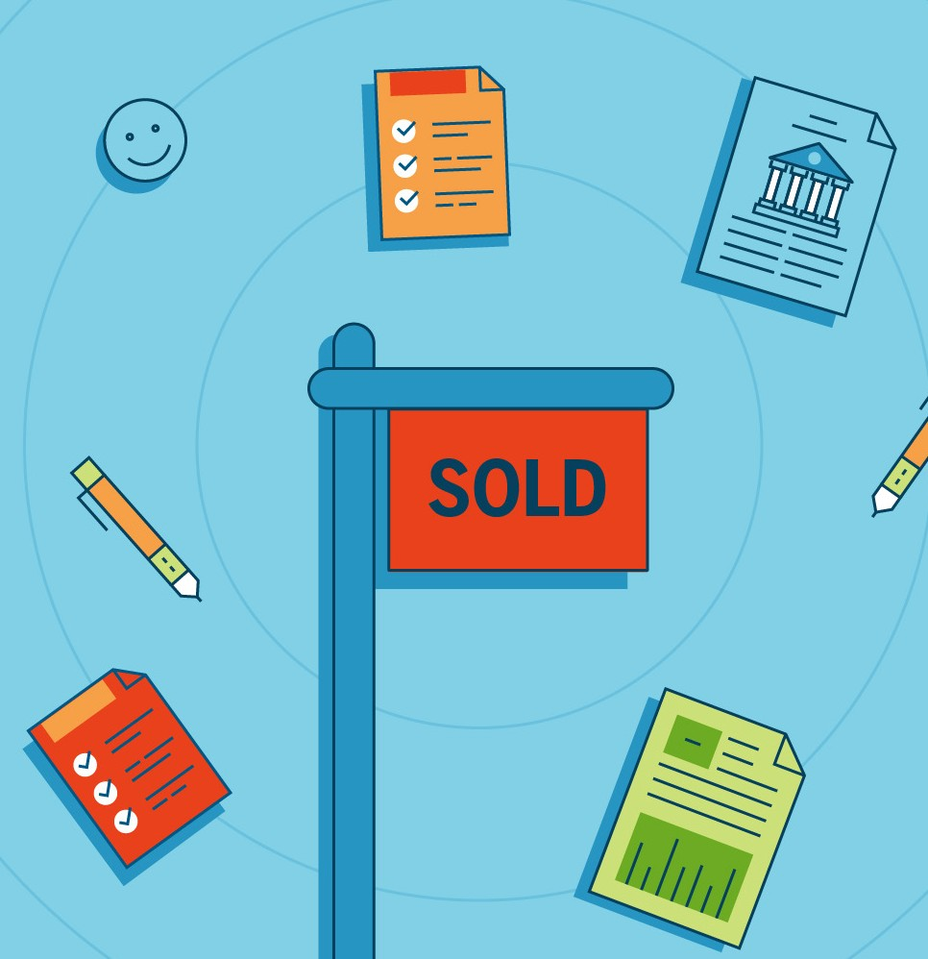
Closing costs for sellers typically include:
- The commission for the listing agent and buyer’s agent
- Transfer taxes or recording fees
- Loan payoff costs
- Unpaid homeowner association dues
- Homeowner association dues included up to the settlement date
- Prorated property taxes
- Escrow, title, or attorney fees

Be Sure to Bring These Things to Closing
At the closing you should have:
- A government-issued photo ID
- A copy of the ratified sales contract
- House keys, garage remotes, mailbox keys, gate keys, and any pool keys
- A cashier’s check, or proof of wire transfer, if your closing costs are not being deducted from the sales price. (Yes, it’s OK to use a cashier’s check — especially if you don’t want to deal with the hassle of a wire transfer, which can take time to clear. With a cashier’s check, you’re guaranteed the money you need for settlement will be there at closing.)

Don’t Forget to Dot These I’s and Cross These T’s
Before you rush off to pick out paint samples for your new place, remember to do these two steps that are often overlooked by sellers:

Transfer utilities. Don’t want to pay for the new owner’s utility bills? Coordinate with the buyer so that utilities
— including not only gas and electric but also water and cable — are transferred to the buyer on closing day.

Change your address. You obviously want your mail to be sent to your new home. Setting up a forwarding address will also ensure that you can be reached if there are any post-closing matters. You can file a change of address with the U.S. Postal Service.

Finally: Celebrate!
At last, your home is officially sold. Congratulations!

Give yourself a pat on the back — and then start settling into your new phase of life.

